**Introduction:**

This documentation will provide a guide to replicating the experiments of

“Experimental Evaluation of the Age ofInformation via Emulation”, a paper that is attached in the following github link: <https://github.com/Johnmancini30/CORE_Research>

**Downloads:**

To run these experiments, you will need to download, CORE, EMANE, and Python3.

To download CORE: <http://coreemu.github.io/core/install.html>

To download EMANE: <https://github.com/adjacentlink/emane/wiki/Install>

To download Python3: <https://www.python.org/downloads/>

**Experimentation:**

To begin, you will need to gather data. Start the CORE daemon in the command line with

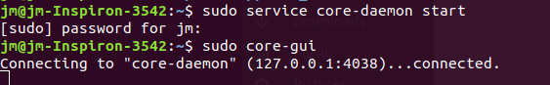

Create the following traffic setup:

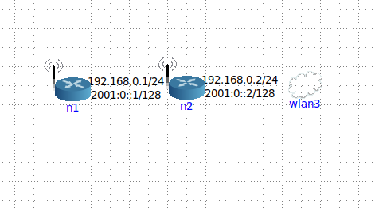

Link all the nodes together with the link tool, and then configure each (right click and click configure) of them to have .1 delay and .1 jitter in he MAC options of the EMANE-RFPIPE menu, and then set their subnet to 24. Do this for all nodes.

Go to the tools option and click traffic. The following is an example of a traffic flow with n1 as source, n2 as destination, creating UDP packets with a Poisson arrival distribution and interarrival rate of 10 packets/second where each packet is 125 bytes.

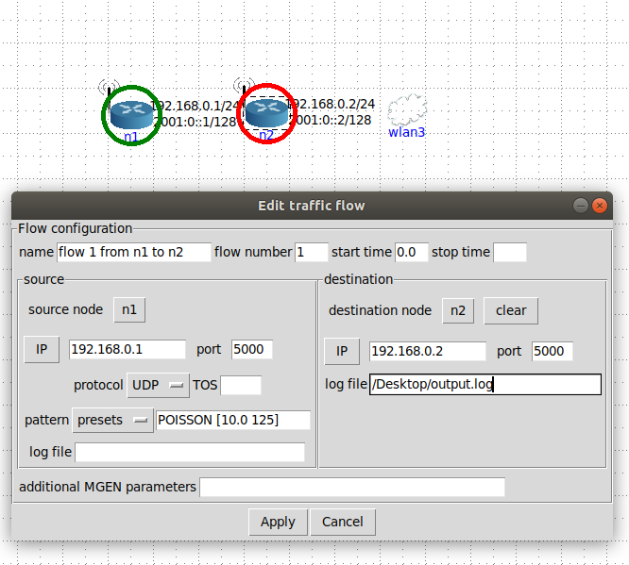

Start the session, wait about 20 seconds. Then open the traffic menu again and start the selected flow. The flow will stop accepting packets after your stop time, but you need to manually stop the flow eventually. Then you can stop the traffic flow entirely. After that, you will see a log file where you specified.

Next you want to generate latency files, and then age files from the MGEN files.

You can use the parser here:

<https://github.com/Johnmancini30/CORE_Research/tree/master/parser>

Setup all of your logged mgen files in a directory, and make sure the string “traffic” is in them. I suggest listing them in order from when you created them, and keeping track of of what the integer means.

So if you had files “traffic1.log”, “traffic2.log”, “traffic3.log”, just make sure you know what parameters 1, 2, and 3 correspond to respectively.

Use the parser.py file function create_files() to generate all of the corresponding age files. After that, go into the analysis file and run the plot_age file. Obviously apply the corresponding arguments where necessary.